WOMBAT

WOMBAT is an acronym for „Wide Ocular Motor Based Automatic Tracker”. Let’s stick with WOMBAT! (The other wombat also has a wide stable base and once it’s decided on a track will not deviate!).

The circuit controlling the WOMBAT has two sensors for detecting a black path placed on a white surface. The amount of light reflected from the surface and, therefore, the amount of light detected by the light sensors, controls the amount of current passing through the motors. This provides the steering for the WOMBAT.
The WOMBAT allows the student to learn and practice the skills required for design and manufacture. The added bonus is that the kit gives students practice in mechanical, electrical, electronic and PCB work.

There are many areas that could be used for further investigation e.g.
- Materials – pros/cons of different materials for the chassis (e.g. plywood, acrylic, CDs).
- Design new chassis shape
- The advantages/disadvantages of using different gear ratios
- Design a simple or complex track without sharp corners. Predict how the WOMBAT will travel.
- Investigate what happens if the track crosses at one point
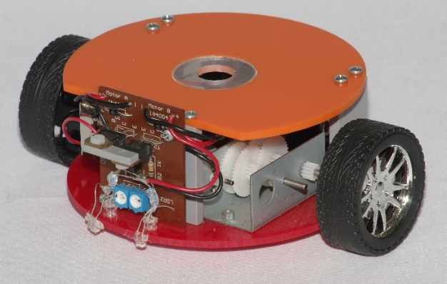
- Compete in a competition to determine the best WOMBAT in your class.
Prototype of the Scorpio WOMBAT
Level:  Type:  Hours required to construct:  Scorpio Code:  Cost: | Advanced kit  Mechanical, Electrical, Electronic, PCB  Approx.18  WOMBAT  1-19 kits $18.26 ea  20+ kits $17.74 ea

References used:
Wombat photo: http://bollygum.com.au/2015/06/13/wombats/

JUMPING BUG & PROJECT SHEET
We still have some introductory packs available. Please take advantage of this special offer. A perfect fun project for end of year activities!

To be eligible you need to:
- Be one of the first 25 Scorpio Newsletter readers to send an email to sales@scorpiotechnology.com.au (Australian entries only).
- Subject: FREE Wind-Up clockwork mechanism
- The email must include a commentary telling us what you have liked / disliked in our Newsletters. Ideas for future Newsletters are always welcome.
- Scorpio Technology Manager has the final say in the distribution of the mechanisms and Project sheet. No correspondence will be entered into.
Keep a look out for our new website with lots of new info & ideas!

WOMBAT RACE COMPETITION
After the WOMBAT has been constructed you may like to run a competition with your students.

COMPETION GUIDELINES:

- Students design a challenging racecourse including straight lines and easy curves.
- Maximize the number of right-hand and left-hand turns.
- Keep all curves as part of the circumference of a 38cm diameter circle.
- No lines will cross or be closer than 10.5cm of any other line.
- The course will be closed. i.e. the line will form a complete path.
- Make the black lines using black electrical tape. You may want to use a white surface such as melamine or a whiteboard.
- The starting line and the finishing line are to be located in the straight section of the circuit.
- During the competition the WOMBAT must not leave the track. If it leaves the black line, and has not crossed the finishing line, it will be considered to have gone off the track, and that run shall be invalid.
- At no time is the WOMBAT allowed to skip a portion of the course.
- Time each WOMBAT to determine which moves around the course the fastest. The challenge will be to complete the course faster than other competitors.
- The lap time will begin when the WOMBAT first crosses the starting line and will end when the WOMBAT crosses the line again.
- Winners are determined by the shortest time to complete two laps around any course.
Scoring – Each run will be scored based on the base time for the run, to which any earned penalty seconds will be added. Penalties are assessed as follows:
Reason for Penalty | Seconds Penalized
Losing the line (when no part of the body of the WOMBAT is over the line)
WOMBAT reacquires the line with no help | +2 secs
WOMBAT reacquires the line with human assistance | +5 sec
WOMBAT reacquires the line with the use of human assistance twice within 15.5cm | +10 secs
Breakdown (refusing to run for any reason) | End of attempt
Requiring more than 10 human interventions in a single run | End of attempt

Racecourse examples:
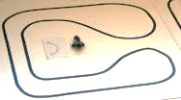 | 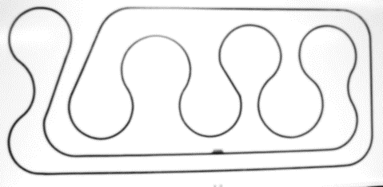
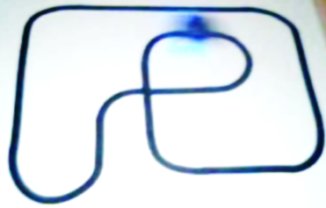 | 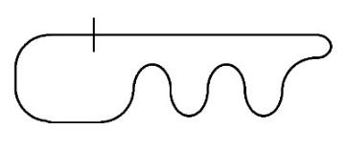
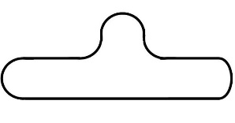 | 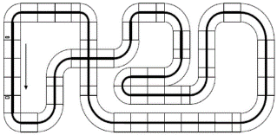
Competition adapted from:
http://www.richardvannoy.info/contest-rules.php
http://projects.granzeier.com/line-follower-contest-ppe13/
http://wiki.ottawarobotics.org/index.php?title=Line_Follower_Race_Rules
http://www.meetup.com/San-Diego-Robotics-Club/

