MOTOR SPEED CONTROLLER

***SCORPIO TECHNOLOGY*** VICTORIA PTY. LTD.

A.B.N. 34 056 661 422

17 Inverell Ave., Mt. Waverley, Vic. 3149 Tel: (03) 9802 9913 Fax: (03) 9887 8158

*Revised: 18 February 2016* [www.scorpiotechnology.com.au](http://www.scorpiotechnology.com.au/) sales@scorpiotechnology.com.au

*Issued: 17 February 2013* [www.scorpiotechnology.com.au](http://www.scorpiotechnology.com.au/) sales@scorpiotechnology.com.au

|  |  |
| --- | --- |
| CONTENTS: |  |
| Section 1: General and Planning Information  Section 2: Components and Material Required  Section 3: PCB Assembly | Section 4: Testing  Section 5: Theory |

|  |  |
| --- | --- |
| DESCRIPTION  The MOTOR SPEED CONTROLLER controls the speed of DC motors or acts as a light dimmer.  Powering an electric motor directly from a battery or power supply will only allow a motor to function at a constant speed. The speed of the motor is directly related to the voltage of the battery or power supply. | C:\1 SCORPIOTECHNOLOGY\7 COMPONENTS & KITS\01PVA Tecwrite photos of kits and protos\Scorpio_Photos\Reduced 25%\2015 Scorpio Prototypes\Motor Speed Controller.jpg |

The MOTOR SPEED CONTROLLER circuit allows the user to adjust the speed of a motor from anywhere between a stopped state up to full speed. The same system can be used as a light dimmer for a 6Volt bulb.

The circuit uses Pulse Width Modulation (PWM) to control the speed of the motor. The way Pulse Width Modulation is used to control motor speed is explained later in this Teaching Unit. This circuit will work with any motor sold by Scorpio Technology. This kit does not contain a motor nor a light bulb.

# General and Planning Information

1. DESIGN CONSIDERATIONS

## ITEMS FOR INVESTIGATION

Some ideas for investigation are listed below.

* Investigate the efficiency of the circuit.
* Investigate the linearity of the speed control.
* Investigate the output torque with respect to the speed.

|  |
| --- |
| Components & Material Required |

## COMPONENTS SUPPLIED

The following components are supplied in the kit:

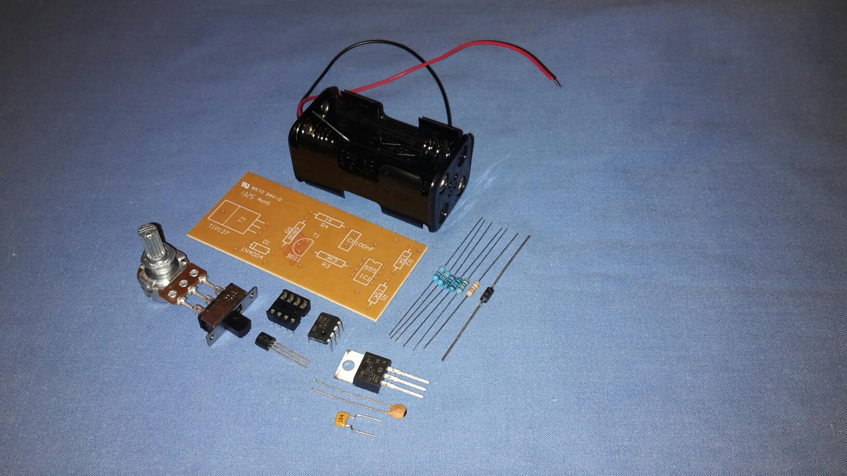

## ADDITIONAL REQUIREMENTS

The following items are required and are available from Scorpio Technology:

* Battery – AA, 4 required (BATTAA)

The following items are to be supplied by the student / designer:

* Aluminium sheet – 1mm thick x 80mm x 16mm
* Electric hook-up wire – Multi-strand in red and black
* 3mm bolt and nut

## TOOLS REQUIRED

The following tools are required:

* Assorted hand tools
* Drill Bit – 3.0mm
* Heatsink compound
* Pliers – Needle nose – Insulated
* Side cutter
* Solder – 60/40, 0.71mm diameter – multicore flux
* Soldering equipment

|  |
| --- |
| PCB Assembly |

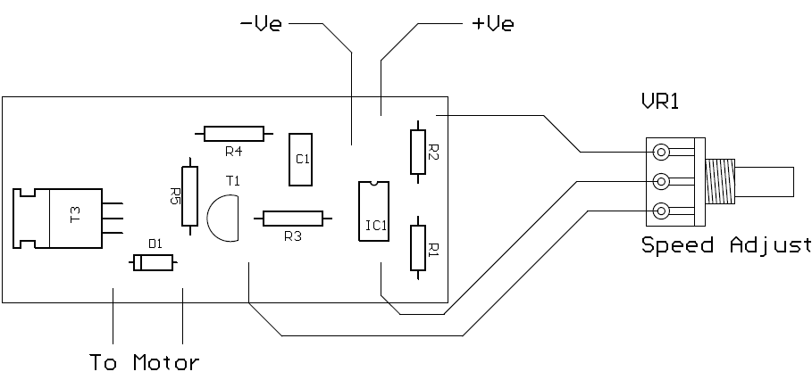

## MOUNTING THE COMPONENTS

The assembly of the components should be carried out before soldering the components in place. Begin with the components that sit lowest on the PCB. All components are mounted on the side without tracks.

Mount the resistors in place. Resistors are non-polarised components and do not need to be placed in any particular direction. However, the convention is that horizontal resistors are mounted with the gold band to the right and for vertical resistors the gold band is to the bottom.

Make sure when mounting the diode D1 that the negative end (the one with the band) is mounted in the same direction as shown on the PCB. They must be connected the correct way for the PCB to work.

The IC is mounted next. Make sure that the notch on the socket faces in the same direction as indicated on the PCB.

The capacitor is mounted next. The capacitor is not polarised and can be mounted in either direction, but it is preferable to mount it with the printed value visible (i.e. facing you).

The transistor is mounted next. It must be mounted facing in the correct direction or it will be damaged when the PCB is connected to power.

The TIP transistor is last component to be inserted. Position the leads in their holes so that the metal back is facing towards the left hand end of the PCB. Press on the plastic section of the transistor and carefully bend it down on to the PCB.

## INSPECTION

Turn over the PCB and slightly bend the leads of the components outwards, to prevent them slipping out when soldering.

Check that all the components are in their correct positions. It pays to spend some time doing this before soldering components in place. It can prevent wasted time later on, trying to find out why the circuit is not working and unsoldering and replacing damaged or wrongly positioned components.

## SOLDERING

Apply the soldering iron tip to the component lead and pad at the same time. Heat the joint for 2-3 seconds and then apply the solder to the heated lead and pad on the opposite side to the soldering iron tip. Melt the solder onto the hot pad and lead, not onto the soldering iron.

Once all the components have been soldered, use a pair of side cutters to cut off the ends of the leads as close as possible to the solder.

## INSTALLING THE INTEGRATED CIRCUIT

After the soldering has been completed, install the 555 IC in the socket. Ensure the notch on the end faces in the same direction as on the socket. Check that the legs line up with the IC sockets holes and press down firmly with your thumb. It may be necessary to push the legs of the IC together slightly to line them up with the socket holes.

## CONNECTING THE POTENTIOMETER

You will need three lengths of insulated wire about 100mm long, but keep the wires as short as reasonably possible. To follow convention, use red for positive and black for negative.

Strip the insulation from about 5mm on each end of the wire. Twist the ends of each wire and “tin” them using solder. Apply solder to the potentiometer terminals to “tin” them.

Solder the wires to the potentiometer. Insert the wires into the holes shown on the PCB diagram and solder them in place.

## MAKING A HEATSINK

|  |  |
| --- | --- |
| The TIP transistor will get hot during operation. If the motor you are using draws a large current, the transistor may overheat. A small heat sink can be fitted to keep the transistor within its safe operating temperature. |  |

Cut 1mm thick sheet aluminium to 80mm x 16mm. Bend at right angles 30mm from each end into a U-shape. Slide the 20mm wide section under the Transistor. Line up the bottom edge of the heatsink with the bottom edge of the Transistor’s body. Mark the centre of the Transistor’s hole and drill a 3mm hole through the heatsink and PCB. Use heatsink compound on the back of the Transistor and then use a 3mm bolt and nut to secure the heatsink in place.

# TESTING

## TESTING

* Turn the potentiometer completely anti-clockwise.
* Connect the battery pack or power supply to the PCB, making sure that positive (+) and negative (-) go in their correct positions.
* Switch on the MOTOR SPEED CONTROLLER. At this stage the motor should not be turning. If the motor turns, this indicates that the potentiometer has been wired incorrectly and you will need to reverse the wires connected to the outer terminals.
* Turn the potentiometer slowly clockwise. The motor should begin to turn and will increase in speed as you turn the potentiometer fully clockwise.
* If the motor does not turn or its speed does not vary, turn off the power and begin troubleshooting

## TROUBLESHOOTING

* If the motor rotates in the wrong direction (backwards), reverse the wires to the motor.
* If nothing happens, or you cannot adjust the motor speed: turn the switch off immediately and check all of the components. Components IC1, D1, T1 and T2 must be in the right positions and facing in the correct direction (check against the information in the Section on assembling the PCB).
* If the components are correctly located and oriented, check the soldering. Make sure there are no dry joints (the soldering may look dry or lumpy). Also check for short circuits, which is where solder connects across from one track to another track.

# THEORY

## INTRODUCTION

When a motor is connected to a fixed voltage it will travel at a set speed. If you reduce the voltage to the motor, the motor’s speed will also be reduced.

If the voltage to the motor remains fixed, how can the motor’s speed be varied?

The function of the motor speed controller is to allow this to be achieved. The motor speed controller works on the principal of Pulse Width Modulation (PWM). The MOTOR SPEED CONTROLLER produces a waveform, which is a series of pulses. These pulses switch between zero and 6 volts. The duration for one cycle a pulse takes is fixed, in other words the operating frequency remains the same. If the time the waveform spends at 6 volt is short compared to the time the waveform is at zero volts then motor speed will be slow. If you increase the time the waveform spends at 6 volts the motor speed will increase.

The speed depends on the average voltage at the motor. If the voltage is present for 10% of the time the average voltage is one tenth of 6 volts (0.6 volts). If it is present for 50% of the time then the average voltage will be 3 volts (half of 6 volts). If the voltage is present for 90% of the time the average will be 5.4 volts.

This method can be used to control the speed of a motor or to control the brightness of a globe.

|  |  |
| --- | --- |
| PWM Signals | **Low Speed**  **Medium Speed**  **High Speed** |

## CIRCUIT DESCRIPTION

The circuit is based on a 555 timer. This is connected as an astable multivibrator whose output frequency is fixed at 320 Hz. The operating frequency is determined by the values of capacitor C1 and the resistors R1 and R2. The duty cycle of the waveform can be adjusted by varying potentiometer VR1. The output of IC1 from pin 3 is connected to the base of transistor T1, which drives transistor T2. T2 is used to control the motor in response to the PWM signal available at its base. Diode D1 is used to protect the rest of the circuit from damage due to voltage spikes caused by the operation of the motor.